Conforms to HazCom 2012/United States
SAFETY DATA SHEET
Iron Ore

Section 1. Identification

GHS product identifier : Iron Ore
Other means of identification : Iron Ore
Identified uses : Used in cement manufacturing, and landscaping
Supplier's details : Pete Lien & Sons, Inc.
PO Box 440
Rapid City, SD 57702
Emergency telephone : (605) 342-7224 (Monday-Friday 8am-5pm)
number (hours of operation)

Section 2. Hazards identification
Classification of the : SKIN IRRITANT – 2
substance or mixture EYE IRRITANT – 2B
SPECIFIC TARGET ORGAN TOXICITY SINGLE EXPOSURE [Respiratory System] - Category 3
Repeated Exposure
CARCINOGEN - Category 2
GHS label elements
Hazard pictograms : 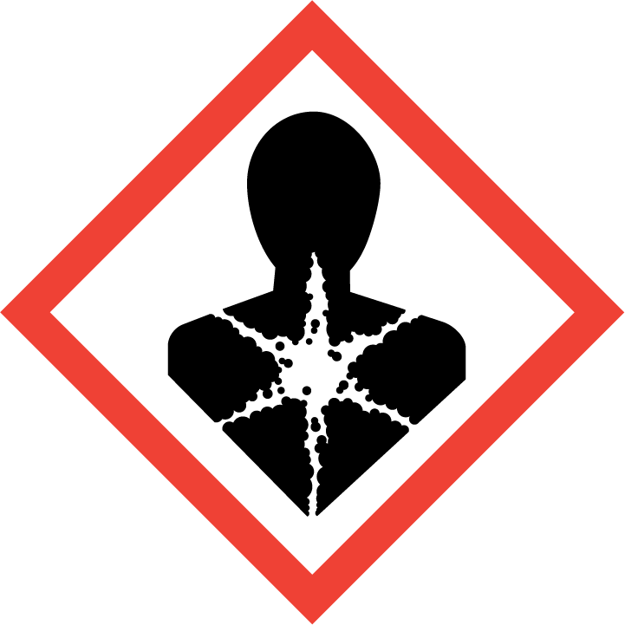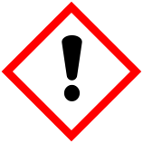

Signal word : Warning
Hazard statements : Causes skin irritation. Causes eye irritation, Suspected of causing cancer. May cause respiratory irritation.
Precautionary statements
Prevention : Wash thoroughly after handling. Do not eat, drink or smoke when using this product.
Obtain special instructions before use. Do not handle until all safety precautions have been read and understood. Wear protective gloves/protective clothing/eye protection/face protection. Avoid breathing dust. Use only outdoors or in a well-ventilated area.
Response If on skin: Wash with plenty of soap and water.
If skin irritation occurs: Get medical advice/attention. Take off contaminated clothing and wash it before reuse.
If in eyes: Rinse cautiously with water for several minutes. Remove contact lenses, if present and easy to do. Continue rinsing. If eye irritation persists: Get medical advice/attention.
If inhaled: Remove person to fresh air and keep comfortable for breathing. Call a poison center/doctor if you feel unwell.
If inhaled excessively: Remove person to fresh air and keep comfortable for breathing.
If in eyes: Rinse cautiously with water for several minutes. Remove contact lenses, if present and easy to do, and continue rinsing.
If exposed, concerned, unwell, or irritation of the eyes, skin, mouth, or throat/nasal passage persist: Get medical attention.
Storage : Store in an appropriate container or containment structure.
Disposal : Dispose of contents/container in accordance with local/regional/national/international regulations.
Hazards not otherwise : None known
classified
Ingredients with : Not Applicable
unknown toxicity
Supplemental Information:
Respirable Crystalline Silica (RCS) may cause cancer. Iron Ore is a naturally occurring mineral complex that contains varying quantities of quartz (crystalline silica). In its natural bulk state, Iron Ore is not a known health hazard. Iron Ore may be subject to various natural or mechanical forces that produce small particles (dust) which may contain respirable crystalline silica (particles less than 10 micrometers in aerodynamic diameter). Repeated inhalation of respirable crystalline silica (quartz) may cause lung cancer according to IARC and NTP; ACGIH states that it is a suspected cause of cancer. Other forms of RCS (e.g., tridymite and cristobalite) may also be present or formed under certain industrial processes.

Section 3. Composition/information on ingredients
Substance/mixture : Iron Ore

CAS number/other identifiers
Component CAS # % by weight
Iron Oxide 1309-37-1 >30
Fe₂O₃
Impurities : Product may contain >0.1% crystalline silica. Moisture content and Impurities will vary from source to source.

Section 4. First aid measures
Description of necessary first aid measures
Eye Contact : Contact can cause irritation of eyes. Immediately flush eyes with generous amounts of water for at least 15 minutes. Pull back the eyelid to ensure that all Iron Ore dust has been washed out. Remove contact lenses, if present and easy to do and continue rinsing. Beyond flushing do not attempt to remove material from the eye(s). Seek medical attention if irritation develops or persists.
Skin Contact : Wash exposed area with soap and water after manually handling and wash contaminated clothing if there is potential for direct skin contact. Seek medical attention if irritation develops and persists.
Ingestion : Do not induce vomiting. If conscious give person 1 to 2 glasses of water. If vomiting occurs spontaneously, lower head to avoid aspiration into lungs. Seek medical attention immediately.
Inhalation : Move to fresh air. Dust in nose and throat should clear spontaneously. Seek medical attention if irritation persists or develops later.
Most important symptoms/effects, acute and delayed : Long-term exposure by inhalation may cause permanent damage. This product contains crystalline silica, which has been classified by IARC as (Group I) carcinogenic to humans when inhaled. Inhalation of silica can also cause a chronic lung disorder, silicosis.

Direct skin and eye contact with dust may cause irritation by mechanical abrasion. Some components of the product are also known to cause irritation to skin, eyes and mucous membranes. Inhalation of dust may irritate nose, throat, mucous membranes and respiratory tract. Coughing, sneezing, chest pain, shortness of breath, inflammation of mucous membrane, and flu-like fever may occur following exposures in excess of appropriate limits. Repeated excessive exposure may cause pneumoconiosis, such as silicosis and other respiratory effects.

Indication of immediate medical attention and special treatment needed, if necessary: See first aid information above. Note to Physicians: Provide general supportive measures and treat symptomatically.

Section 5. Fire-fighting measures
Extinguishing Media : Not Flammable; use agent most appropriate to extinguish surrounding fire.
Unsuitable Extinguishing Media: None known
Fire Hazards : None known
Hazardous Combustion Products: None known
Special Protective Equipment and Fire Fighting Instructions:
Use protective equipment and appropriate for surrounding materials.

Section 6. Accidental release measures
Personal precautions, protective equipment and emergency procedures
Spill/Leak Procedures : Persons involved in cleaning should first follow the precautions defined in Section VII of the SDS. Spilled material, where dust is generated, may overexpose cleanup personnel to respirable crystalline silica-containing dust. Avoid generating dust. Do not clean up with compressed air or dry sweep. Wetting of spilled material and/or use of respiratory protective equipment may be necessary. Wear appropriate personal protective equipment as specified in Section VIII including appropriate respirators during and following clean up or whenever airborne dust is present to ensure worker exposures remain below occupational exposure limits.
Methods and materials for containment and cleaning up
Containment : Place dust in a covered container appropriate for disposal. Dispose of the dust according to federal, state, and local regulations.
This product is not subject to the reporting requirements of SARA Title III Section 313, and 40 CFR 372.

Section 7. Handling and storage
Handling Procedures :Avoid dust contact with eyes. Wear the appropriate eye protection against dust. Minimize dust generation and accumulation. Avoid breathing dust. Wear the appropriate respiratory protection against dust in poorly ventilated areas and if TLV is exceeded. Use good safety and industrial hygiene practices.
Storage Procedures :Store in a ventilated area away from sources of heat, moisture and incompatible materials.
Incompatibilities :None.
Section 8. Exposure controls/personal protection
Exposure limits
Component CAS # Exposure limits
Iron Oxide 1309-37-1 OSHA PEL: 10mg/m³ TWA(fume)
ACGIH: 5mg/m³ TWA(respirable fraction)
NIOSH: 5mg/m³ TWA(dust and fume, as Fe)

Crystalline Silica 14808-60-7 OSHA PEL: 10mg/m³ divided by (the percentage of silica in the
SiO₂ dust plus 2) (respirable)
ACGIH TLV: 0.025 mg/m³ (respirable)

Engineering controls
Ventilation: Use local exhaust, general ventilation or natural ventilation adequate to maintain exposures below appropriate exposure limits.

Other control measures: Respirable dust and crystalline silica levels should be monitored regularly. Dust and crystalline silica levels in excess of appropriate exposure limits should be reduced by implementing feasible engineering controls, including (but not limited to) dust suppression (wetting), ventilation, process enclosure and enclosed employee work stations.

Individual Protection Measures
Respiratory Protection : Avoid actions that cause dust exposure to occur. Use local or general ventilation to control exposures below applicable exposure limits. NIOSH or MSHA approved particulate filter respirators should be used in the context of respiratory protection program meeting the requirements of the OSHA respiratory protection standard [29 CFR 1910.134] to control exposures when ventilation or other controls are inadequate or discomfort or irritation is experienced. Respirator and/or filter cartridge selection should be based on American National Standards Institute (ANSI) Standards Z88.2 Practices for Respiratory Protection.
Skin Protection : Where prolonged exposure to products might occur, wear impervious gloves to eliminate skin contact. Normal work clothing (long sleeved shirts and long pants) is recommended.
Eye Protection : When engaged in activities where ingredients could contact the eye, wear safety glasses with side shields or goggles. In extremely dusty environments and unpredictable environments, wear unvented or indirectly vented goggles to avoid eye irritation or injury. Contact lenses should not be worn when working with ingredients.
Thermal Hazards : Not Anticipated. Wear appropriate thermal protective clothing, when necessary.
General Hygiene : There are no known hazards associated with this material when used as recommended. Following the guidelines in this SDS are recognized as good industrial hygiene practices. Avoid breathing dust. Avoid skin and eye contact. Wash dust-exposed skin with soap and water before eating, drinking, smoking and using toilet facilities. Wash work clothes after each use.

Section 9. Physical and chemical properties
Physical State : Solid
Appearance : Red to black
Odor : No Odor
Odor threshold : Not applicable
pH at 25 degrees C : Not applicable
Melting point : Not applicable
Initial boiling point : Not applicable
Flash point : Not applicable
Evaporation rate : Not applicable
Flammability (solid, gas) : Not applicable
Lower and upper explosive : Not applicable
(flammable) limits
Vapor pressure : Not applicable
Vapor density : Not applicable
Specific Gravity : Not Determined
Solubility in water : Negligible
Partition coefficient: n : Not applicable
octanol/water
Auto-ignition temperature : Not applicable
Decomposition temperature : Not applicable
Viscosity : Not applicable

Section 10. Stability and reactivity
Reactivity : This product is stable and non-reactive under normal conditions of use, storage and transport.
Chemical stability : Material is stable under normal conditions
Possibility of : No dangerous reaction known under conditions of normal use.
hazardous reactions
Conditions to avoid : Contact with incompatible materials.
Incompatible materials : None
Hazardous : None
decomposition
products
Section 11. Toxicological Information
Component Analysis - LD50/LC50
Iron oxide (Fe2O3) (1309-37-1)
Oral LD50 Rat >10000 mg/kg
Skin Corrosion Property :Exposure to granular material could cause skin abrasion.
Eye Critical Damage :Dust can cause mechanical irritation of eyes. Possible destruction of eye tissue if dust is not washed from the eye.
Ingestion :Ingestion of large amounts may cause gastrointestinal harm.
Inhalation :Exposure to dust generated during the handling or use of the product may irritate eyes, skin, nose, throat and upper respiratory tract.
Respiratory Organs Sensitization/Skin Sensitization
This product is not reported to have any sensitization effects.
Generative Cell Mutagenicity
This product is not reported to have any mutagenic effects.
Carcinogenicity
A: General Product Information
Suspected of causing cancer.
B: Component Carcinogenicity
Iron oxide (Fe2O3) (1309-37-1) ACGIH: | A4 - Not Classifiable as a Human Carcinogen
IARC: | Supplement 7 [1987]; Monograph 1 [1972] (Group 3 (not classifiable))
Reproductive Toxicity
This product is not reported to have any reproductive toxicity effects.
Specified Target Organ General Toxicity: Single Exposure
This product is not reported to have any single exposure specific target organ toxicity effects.
Specified Target Organ General Toxicity: Repeated Exposure
May cause respiratory irritation.
Aspiration Respiratory Organs Hazard
This product is not reported to have any aspiration hazard effects.

Section 12. Ecological information
Ecotoxicity : There is no data available.
Persistence and degradability : There is no data available.
Bioaccumulative potential : There is no data available.
Mobility in soil : There is no data available.

Section 13. Disposal considerations
Disposal Instructions : Collect and reuse clean materials. Dispose of waste materials only in accordance with applicable federal, state, and local laws and regulations.
The above information applies to the product only as sold. The product may be contaminated during use and it is the responsibility of the user to assess the appropriate disposal method in that situation.
Hazardous waste code : Not regulated
Waste from residues/ :Dispose of in accordance with local regulations. Empty containers or liners may retain
unused product some product residues. This material and its container must be disposed of in a safe manner (See disposal instructions)
Contaminated packaging : Since emptied containers may retain product residue, follow label warnings even after container is emptied. Empty packaging materials should be recycled or disposed of in accordance with applicable regulations and practices.
Section 14. Transport information
DOT :Not regulated as dangerous goods

Section 15. Regulatory information

OSHA: Crystalline Silica is not listed as a carcinogen.
SARA Title III: Section 311 and 312: Immediate health hazard and delayed health hazard.
TSCA: Crystalline silica (quartz) appears on the EPA TSCA inventory under the CAS No. 14808-60-7.
RCRA: Crystalline silica (quartz) is not classified as a hazardous waste under the Resource Conservation and Recovery Act, or its regulations, 40 CFR §261 et seq.
CERCLA: Crystalline silica (quartz) is not classified as a hazardous substance under regulations of the Comprehensive Environmental Response, Compensation and Liability Act (CERCLA), 40 CFR §302.4
EPCRA (Emergency Planning and Community Right to Know Act): Crystalline silica (quartz) is not an extremely hazardous substance under regulations of the Emergency Planning and Community Right to Know Act, 40 CFR Part 355, Appendices A and B and is not a toxic chemical subject to the requirements of Section 313.
Clean Air Act: Crystalline silica (quartz) mined and processed by Martin Marietta Materials was not processed with or does not contain any Class I or Class II ozone depleting substances.
FDA: Silica is included in the list of substances that may be included in coatings used in food contact surfaces, 21 CFR §175.300(b)(3).(The FDA standard primarily applies to products containing silica used in the coatings of food contact surfaces).

Section 16. Other information
History
Date of issue (mm/dd/yyyy) : 06/01/2015
Version : 1

Disclaimer: The information contained in this document applies to this specific material as supplied. Pete Lien & Sons, Inc. believes that the information contained in this SDS is accurate. The suggested precautions and recommendations are based on recognized good work practices and experience as of the date of publication. They are not necessarily all-inclusive or fully adequate in every circumstance as not all use circumstances can be anticipated. The suggestions should not be confused with nor followed in violation of applicable laws, regulation, rules or insurance requirement.

It is the user’s responsibility to satisfy oneself as to the suitability and completeness of this information for one’s own particular use. Since the actual use of the product described herein is beyond our control, Pete Lien & Sons, Inc., assumes no liability arising out of the use of the product by others. Appropriate warnings and safe handling procedures should be provided to handlers and users. Product must not be used in a manner which could result in harm.

